**SANTA CRUZ II 2022 ITINERARIES**

**DAY-BY-DAY DESCRIPTIONS**

|  |
| --- |
| TOUR DETAILS |

Tour Name

SANTA CRUZ II Eastern Galapagos. 7 Days/6 Nights (Friday to Thursday)

**Description**Our exploration of the archipelago’s eastern islands has been carefully designed for up-close encounters with nearly all of the BIG15 species, while also allowing us to enjoy some of the islands’ true highlights. San Cristobal Island gives guests the opportunity to experience both the natural and human sides of the Galapagos archipelago. From there, the trip ventures to the unique islands of South Plaza and Santa Fe, before sailing to Santa Cruz with its varied vegetation and activities. Sailing south, we explore the wondrous Española Island before turning north to end with the wonderful North Seymour. Let the adventure begin!

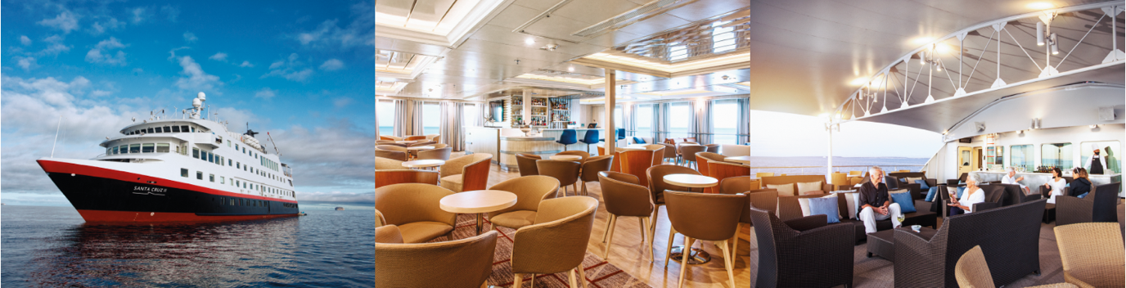 **Day 1- Friday**  
**BALTRA/MOSQUERA**  
  
**Baltra Island**  
We arrive by plane at Baltra Island and transfer to the dock to board the Santa Cruz II where we receive our welcome introductory briefing and lunch.  
  
**Mosquera**After lunch and your introductory briefing on board, Santa Cruz II will relocate only four nautical miles from Baltra, next to Mosquera Islet, a small volcanic uplift between Baltra and North Seymour. The island is a long and narrow sand bank surrounded by lava reefs. Our groups will approach the island from its western shore, a long shallow reef, the perfect rookery for young sea lions. After a wet landing, our guides will lead you past the sea lion colonies, where you will learn more about the fragile marine and terrestrial ecosystems of Galapagos. The walk is easy as it is restricted to a few hundred metres of flat sandy dunes.

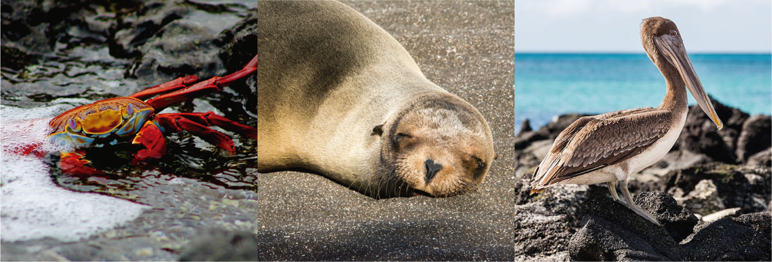

**Day 2- Saturday**

**SAN CRISTOBAL**

**Puerto Baquerizo Moreno (San Cristobal Island)**

After breakfast, we disembark (dry landing) at Puerto Baquerizo Moreno, the island's capital, and drive 40 minutes to the island’s southern shore. At Cerro Colorado, we visit the breeding centre for highly endangered giant tortoises in the midst of a fantastic deciduous forest, home to dozens of bird species, including the San Cristobal mockingbird, and the San Cristobal lava lizard, both island endemics.

**Punta Pitt (San Cristobal Island)**

In the afternoon, we disembark (wet landing) on the eastern tip of the island at Punta Pitt, an eroded tuff cone, whose trail provides spectacular views of the shoreline. This is the only site in the Galapagos where the three species of boobies can be found together. We can walk or enjoy a panga ride along the coast. Opportunity for snorkelling and swimming activities.

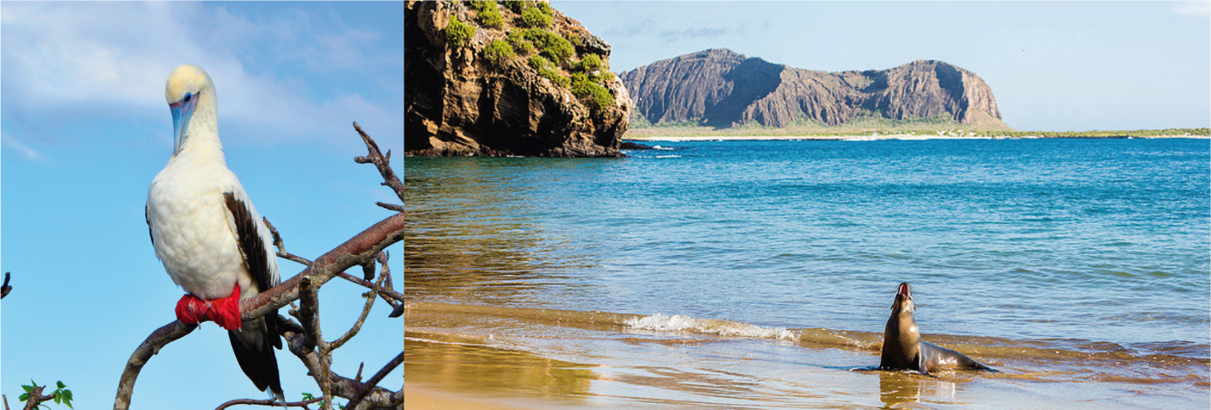

**Day 3- Sunday**

**SANTA FE/SOUTH PLAZA**

**Santa Fe Island**

After breakfast, we take the dinghy over to this idyllic sandy-white beach populated by many sea lions (wet landing). The endemic land iguana, unique to this island, may be spotted during the morning walk amid the giant prickly pear cactus. Snorkelling and swimming from the panga rounds off our rewarding experience, or if guests prefer, the glass bottom boat is available for non-snorkelers. **Opportunity for kayaking.**

**South Plaza Island**

Following lunch and a rest, we disembark (dry landing) in this channel, whose turquoise waters contrast brilliantly with the white sand and black lava of the shoreline. Beyond, a carpet of scarlet sesuvium succulents serves as groundcover for a grove of luminescent green prickly-pear cactus. Yellow-grey land iguanas sit beneath these, waiting patiently for pears to drop. Along the coastline one finds sea lion colonies, while frigates, swallow-tailed gulls and shearwaters glide, playing with the thermals.

**Day 4- Monday**

**SANTA CRUZ**

**Puerto Ayora and the Charles Darwin Research Station (Santa Cruz Island)**

In the morning, we disembark (dry landing) for our visit to the Charles Darwin Research Station’s giant tortoise Breeding Centre within an impressive giant prickly-pear cactus forest home to many land birds. These are the headquarters of scientific investigation, conservation and the National Park administration. Following our visit, we board our transport to enjoy lunch in the cooler highlands of Santa Cruz Island, a completely different ecosystem.

**Santa Cruz Island**

We have several options available for the afternoon, which can be discussed in advance with your Expedition Leader. At the end of the afternoon’s activities, we return to Puerto Ayora and embark on the Santa Cruz II.

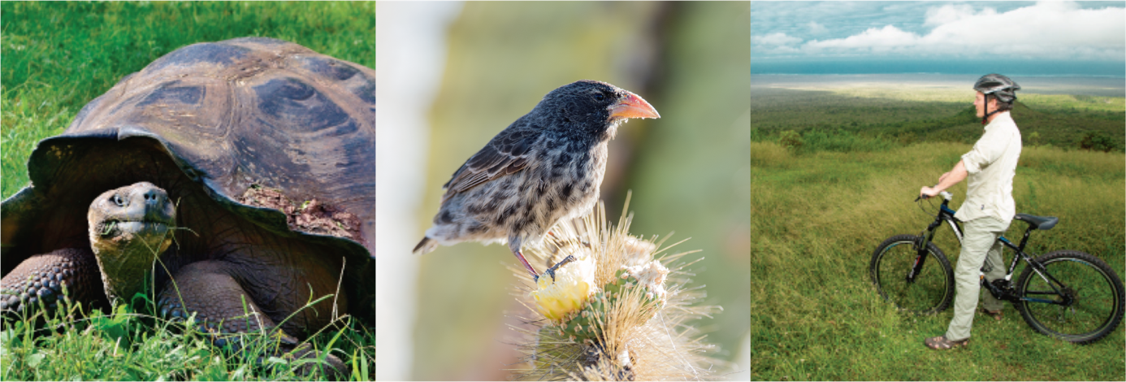

**Day 5- Tuesday**

**ESPAÑOLA**

**Punta Suarez (Española Island)**

(Dry landing) - An exciting walk awaits at this site, where we enjoy its unique sea bird colonies, including waved albatrosses (April-December), Nazca boobies, blue-footed boobies, and swallow-tailed gulls as well as a view of the Española’s famous “blow-hole”. Also, look out for red-green-black marine iguanas. Back on board for lunch.

**Gardner Bay – Osborn Islet (Española Island)**

(Wet landing) In the afternoon, the picture-postcard white coral beach of Gardner Bay and the nearby islet of Osborn provides a beautiful setting for observing sea lions, mockingbirds, and finches as we relax. We can expect great snorkelling in this area. Opportunity for swimming and kayaking as well.

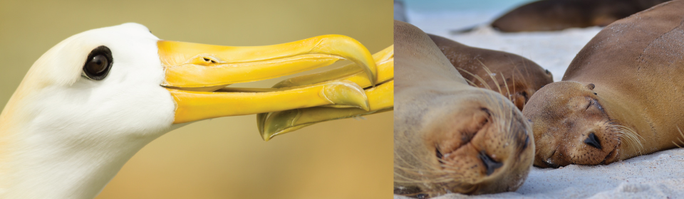

**Day 6- Wednesday**

**SANTA CRUZ/ NORTH SEYMOUR**

**Eden Islet (Santa Cruz Island)**

After breakfast, a panga ride takes us to Eden Islet, a small islet located off the coast of Santa Cruz, where we can observe blue-footed boobies diving into the water, reef sharks and frigates. There’s a chance to snorkel and, if weather condition permits, ride in the glass-bottom boat and kayak.

# North Seymour Island

North Seymourwas lifted from the ocean floor by a volcanic event, and its origins as a seabed give the island its low, flat profile. A tiny forest of the endemic silver-grey Palo Santo trees stands just above the landing (dry landing), usually without leaves, waiting for the rains to burst into bloom. This is a great introductory site to the islands and their wildlife. North Seymour is inhabited by bird colonies such as blue-footed boobies, two species of frigate birds, swallow-tailed gulls, as well as sea lions and marine iguanas. Last chance to practice snorkelling or ride in our glass-bottom boat.

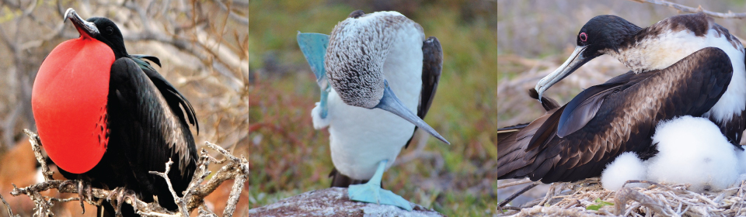

**Day 7- Thursday**

**BALTRA**

**Baltra Island**

On our last day, we disembark at Baltra Island and transfer to the airport to take the flight back to the continent.

**Notes**

Please remember that the exact route and programme may vary according to weather and ocean conditions and the wildlife we encounter. It's also subject to change without previous notice due mainly to readjustment of the National Park policies and regulations.

**-Dry landing**: Guests step from the panga (dinghy) onto rocks or a dock.

**-Wet landing:** As the dinghy edges onto a sandy beach, guests step into around 8 inches (20 cm) of water and wade ashore.

**PACKING CHECK LIST**

* 1 small backpack
* Comfortable walking shoes
* Sneakers with rubber soles
* Shorts
* Long pants
* T-shirts
* Long and short sleeved shirts
* Wind breaker
* Bathing suit or a wetsuit for snorkelling in cold months
* Hat or cap
* Sunblock and repellent
* Sunglasses
* Binoculars
* Camera & video recorder
* Any medicine you may be taking
* Book/Notebook

Included

All meals, island sightseeing, naturalists and lecture services, snorkeling gear, use of kayaks, glass-bottom boat, panga rides and transfers.

Not Included

Air tickets to/from Galapagos, Galapagos National Park admission fee (US $100 subject to change without notice), transit Control Card for Galapagos (US$ 20 per person), wet suits, alcoholic and non-alcoholic beverage, tips, gifts, internet* and additional items.

* Due to the Galapagos’ remote location, internet connections are intermittent and low-bandwidth.